1 Quantitate DNA (Optional)

Run Information
Date
Time
Operator

Robot Information
Robot ID

WG#-DNA Plate
Plate 1 ID
Plate 2 ID
Plate 3 ID

Standard DNA Plate
Plate ID

QNT Plate
Plate 1 ID
Plate 2 ID
Plate 3 ID

Comments

2 Amplify DNA (Pre-Amp)

Run Information
Date
Time
Operator

Robot Information
Robot ID
Plate Position on Robot Bed

Batch Information
Batch Number
Number of Samples

Plates
WG#-DNA Plate ID
MSA3 Plate ID

Reagent Lot Numbers and Bar Codes
MA1
MA2
MSM
0.1N NaOH

☐Vortex plate at 1600 rpm for 1 minute.

☐Centrifuge plate to 280 × g at 22°C for 1 minute.

☐Centrifuge plate to 280 × g at 22°C for 1 minute.

Comments

WG#-DNA Sample IDs
Columns 1 - 4 of the Microtiter Plate
 | 1 | 2 | 3 | 4
A
B
C
D
E
F
G
H
Columns 5 - 8 of the Microtiter Plate
 | 5 | 6 | 7 | 8
A
B
C
D
E
F
G
H
Columns 9 - 12 of the Microtiter Plate
 | 9 | 10 | 11 | 12
A
B
C
D
E
F
G
H

3 Incubate DNA (Post-Amp)

Incubate in Hyb Oven for 20-24 Hours at 37°C.
Start Time
Stop Time

4 Fragment DNA (Post-Amp)

Run Information
Date
Time
Operator

Robot Information
Robot ID
Plate Position on Robot Bed

Reagent Lot Numbers and Bar Codes
FMS

☐Centrifuge tubes to 280 × g.

☐Centrifuge plate to 50 × g for 1 minute.

☐Vortex plate at 1600 rpm for 1 minute.

☐Centrifuge plate to 50 × g for 1 minute.

Heat Block at 37°C for One Hour
Start Time
Stop Time

Comments

5 Precipitate DNA (Post-Amp)

Run Information
Date
Time
Operator

Robot Information
Robot ID
Plate Position on Robot Bed

Reagent Lot Numbers and Bar Codes
PM1
100% 2 Propanol
100% 2 Propanol Date Opened

☐Centrifuge plate to 280 × g for 1 minute.

☐Vortex plate at 1600 rpm for 1 minute.

Incubate at 37°C for 5 minutes.
Start Time
Stop Time

☐Centrifuge plate to 50 × g for 1 minute.

Incubate at 4°C for 30 minutes.
Start Time
Stop Time

☐Centrifuge plate to 3000 × g at 4°C for 20 minute.

Air Dry at 22°C for 1 Hour
Start Time
Stop Time

Comments

6 Resuspend DNA (Post-Amp)

Run Information
Date
Time
Operator

Robot Information
Robot ID
Plate Position on Robot Bed

Reagent Lot Numbers and Bar Codes
RA1

☐Vortex plate at 1800 rpm for 1 minute.

☐Centrifuge plate to 280 × g.

Comments

7 Hybridize DNA (Post-Amp)

Run Information
Date
Time
Operator

Robot Information
Robot ID

Reagent Lot Numbers and Bar Codes
PB2

Heat Block at 95°C for 20 minutes
Start Time
Stop Time

☐MSA3 plate cool down for 30 minutes at room temperature

☐Centrifuge MSA3 plate to 280 × g

Robot Information
Plate Position on Robot Bed

BeadChip 1 Serial Number and Position
BeadChip 2 Serial Number and Position
BeadChip 3 Serial Number and Position
BeadChip 4 Serial Number and Position

☐Centrifuge MSA3 plate to 280 × g.

Hyb Oven Incubation at 48°C for 16 to 24 hours
Start Time
Stop Time

Comments

Track BeadChips 1-4 for the 24x1 HTS BeadChip  Adjustable Spacer Multi-Channel Pipette  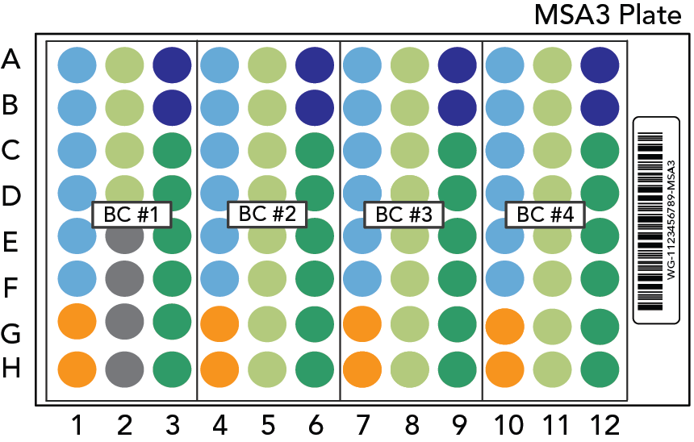 | 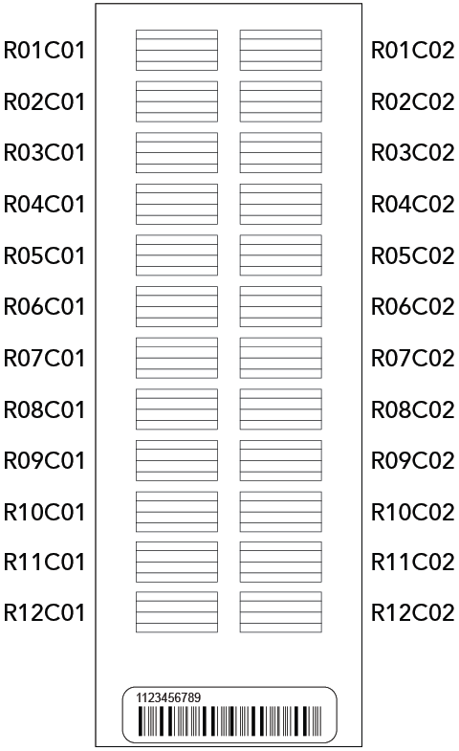 | Sample Section Naming Diagram
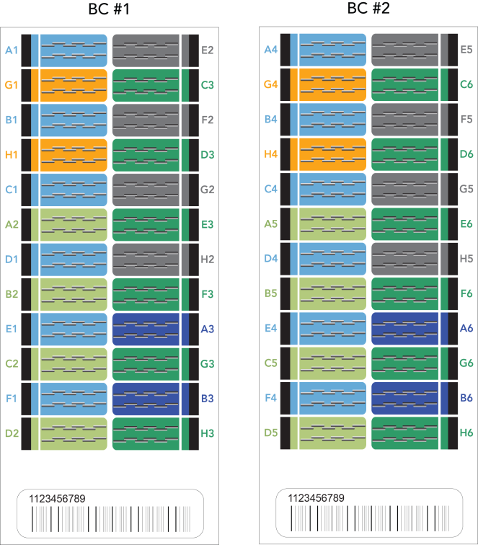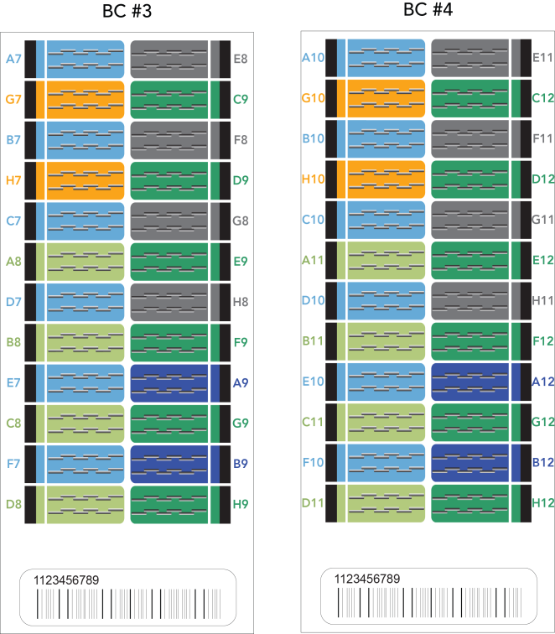

8 Wash BeadChip (Post-Amp)

Run Information
Date
Time
Operator

Reagent Lot Numbers and Bar Codes
PB1

Comments

9 Extend and Stain (XStain) BeadChip (Post-Amp)

Run Information
Date
Time
Operator

Robot Information
Robot ID

Reagent Lot Numbers and Bar Codes
RA1
LX1
LX2
EML
XC3
SML
SML Temperature
ATM
PB1
XC4
Alconox Powder Detergent
EtOH
EtOH Date Opened
95% formamide/1mM EDTA

Dry in Desiccator > 675 mm Hg (0.9 bar) for 50-55 minutes
Start Time
Stop Time

Comments

10 Image BeadChip (Post-Amp)

Run Information
Operator

BeadChip 1
Barcode Number
Scanner ID
Image Date

BeadChip 2
Barcode Number
Scanner ID
Image Date

BeadChip 3
Barcode Number
Scanner ID
Image Date

BeadChip 4
Barcode Number
Scanner ID
Image Date

Comments

